**LAB _DAY-1 (Introduction to Python)**

**Downloading the Python.**

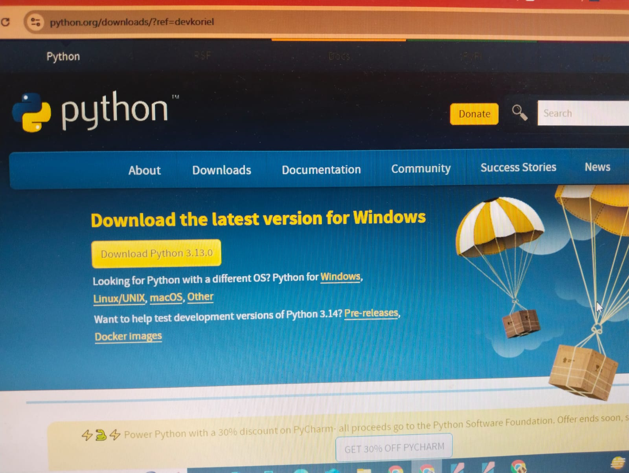

**Installing the Python**

